Assignment
Module 3: Handling Navigation with Routes

a) Make use of JSON server to create a static API (containing courses JSON data)

Setup JSON Server
Install JSON Server
npm install -g json-server

Create a db.json file:
Place the following content in db.json as a starting point

{
"courses": [
{ "id": 1, "name": "React Basics", "description": "Learn the basics of React." },
{ "id": 2, "name": "Advanced React", "description": "Deep dive into React." },
{ "id": 3, "name": "React with Redux", "description": "State management with Redux." }
],
"enquiries": []
}

Run JSON Server :
json-server --watch db.json --port 6700

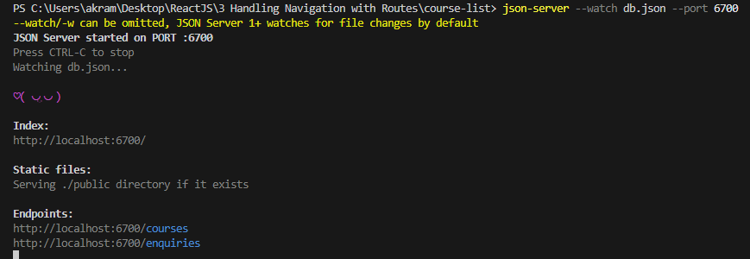

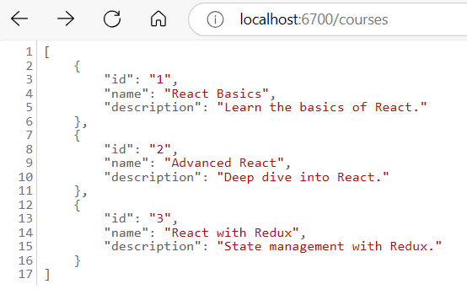
b) Under each course there must be enquire button
c) On clicking enquire button, a form should be displayed. Here user should be able to type their details
d) On clicking the submit button the user information should be added to json file
e) Create one more route to display the user enquires

